## **Introduction**

The Internet is the worldwide "network of networks" that links millions of computers together via copper wires, fiber-optic cables, wireless connections, and other telecommunications channels. This publicly accessible network of interconnected computer networks communicate using a set of protocols and standards, the most basic of which are TCP/IP. The Internet has revolutionized the computer and communications world like nothing before. The invention of the telegraph, telephone, radio, and computer set the stage for this unprecedented integration of capabilities. Internet usage has exploded since 1995, based on researcher’s estimation Internet having 1 billion to 1.5 billion users in 2000 and over 3.4 billion in 2016. The most viewed thing on the internet is websites which is a collection of web pages and related content that is identified by a common domain name and published on at least one web server. Notable examples are wikipedia.org, google.com, and amazon.com. The world's first website was published on August 6, 1991 by British physicist Tim Berners-Lee. The number of website As of January 1st, 2020, there were 1,744,517,326 websites, up from 257,601 in January 1996.This number shows a huge release of website per year that’s why people start to evaluate and categorize websites.

# History of internet

No single person invented the Internet. It was the result of years of collaboration among computer scientists, researchers and engineers. Technology experts cite various government agencies as well as a handful of individuals that have played an instrumental role in creating what we know today as the Internet. The history of the Internet has its origin in the efforts to interconnect computer networks that arose from research and development in 1960’s.The major researches are “Galactic Network” concept by J.C.R. Licklider of MIT in 1962 and U.S. military’s research network dubbed Arpanet in 1969.but the Arpanet research was the best because the first successful message was sent from a computer in UCLA to another computer (also called node) at the Stanford Research Institute (SRI). These computers were called Interface Message Processors (IMP).

The Internet has revolutionized the computer and communications world like nothing before. The invention of the electronic devices set the stage for this unprecedented integration of capabilities. But to be in this stage it passes through different stages the table below shows major changes on internet.

Table : events that modify the internet

|  |  |
| --- | --- |
| year | event |
| **1969** | The first message is "LO," was sent from a computer in UCLA to another computer at the Stanford Research Institute (SRI) by Charles Kline |
| **1972** | Ray Tomlinson introduces network email. The next year the term internet born |
| **1974** | The first Internet Service Provider (ISP) is born with the introduction of a commercial version of ARPANET, known as “Tele net” and Vinton Cerf and Bob Kahn publish "A Protocol for Packet Network Interconnection," which details the design of TCP. |
| **1982** | TCP/IP emerge as the protocol for ARPANET |
| **1983** | The Domain Name System (DNS) established |
| **1987** | The number of hosts on the Internet exceeds 20,000. Cisco ships its first router |
| **1990** | Tim Berners-Lee, a scientist at CERN, the European Organization for Nuclear Research, develops Hypertext Markup Language (HTML) the next year they introduces the World Wide Web to the public. These technologies have large impact on the Internet today. |
| **1994** | Yahoo! is created by Jerry Yang and David Filo |
| **1997** | Netflix is founded by Reed Hastings and Marc Randolph as a company that sends users DVDs by mail. |
| **1998** | The Google search engine is born, changing the way users engage with the Internet. |
| **1998** | The Internet Protocol version 6 introduced, to allow for future growth of Internet Addresses |
| **1999** | AOL buys Netscape. Peer-to-peer file sharing becomes a reality as Napster arrives on the Internet, much to the displeasure of the music industry |
| **2003** | The blog publishing platform WordPress is launched. |
| **2004** | Facebook goes online and the era of social networking begins. Mozilla unveils the Mozilla Firefox browser. |
| **2005** | YouTube.com launches. The social news site Reddit is also founded. |
| **2006** | Twitter launches |
| **2010:** | Facebook reaches 400 million active users. Instagram launched. |

# **Observation on some popular websites**

**IMDb (Internet Movie Database)** is an online database of information related to films, television programs, home videos, video games, and streaming content online – including cast, production crew and personal biographies, plot summaries, trivia, fan and critical reviews, and ratings. An additional fan feature, message boards, was abandoned in February 2017. Originally a fan-operated website, the database is owned and operated by IMDb.com, Inc., a subsidiary of Amazon. As of January 2020, IMDb has approximately 6.5 million titles (including episodes) and 10.4 million personalities in its database, as well as 83 million registered users.

Looking of Imbd website in different years

On Dec 21 1998

* Available on Finland, France Hungary, Italy, Norway, Portugal, Sweden, UK, USA .have site maps like SearchtheDatabase,What's *New at* IMDb*?,* SiteIndex …etc.
* Does not have any background picture
* Page title:-welcome to imdb

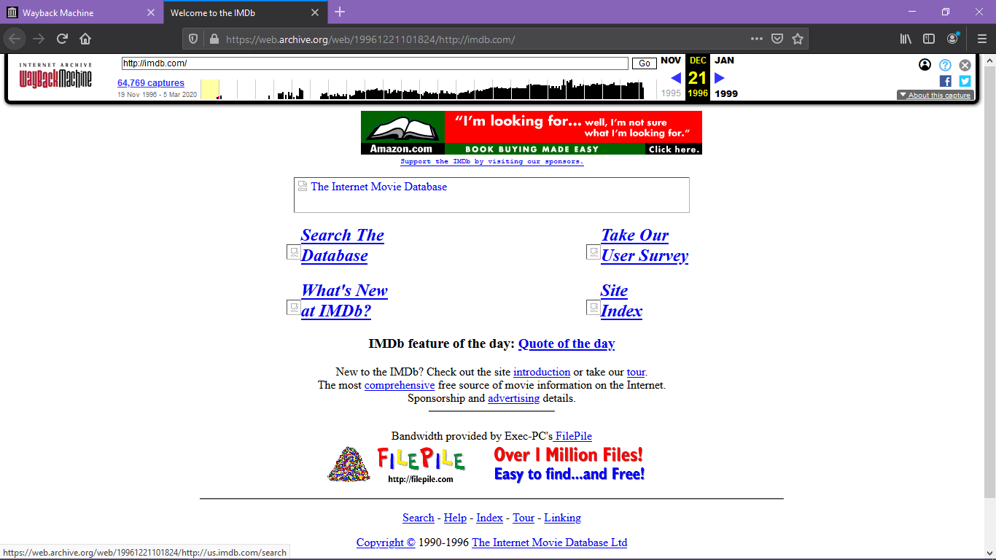

March 30 2001

* Available in three languages
* Have better graphics
* Page title:-the internet movie database

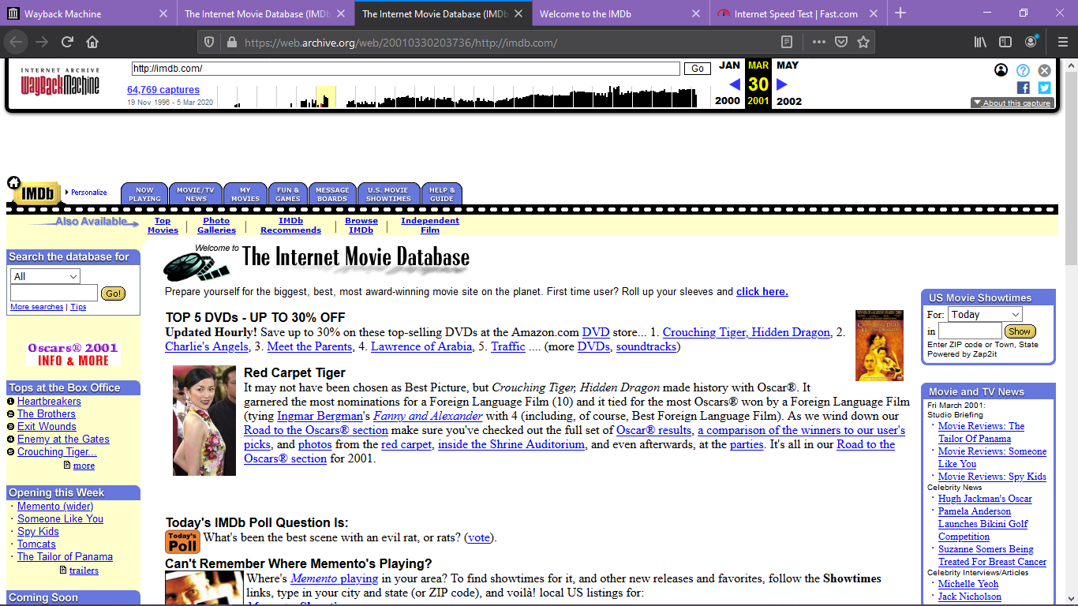

On Oct 03 2010

* Have attractive graphics and news about celebrities added
* Page title:-the internet movie database
* Pro version was added
* Translated to many languages

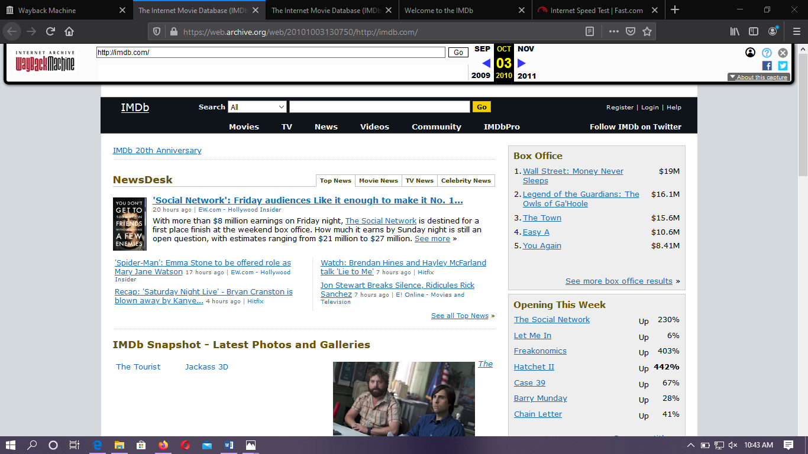

On July 21 2018

* Have a great look and have watch list
* Page title:-Imdb-movies, Tv, celebrities and more...
* Pro version was added

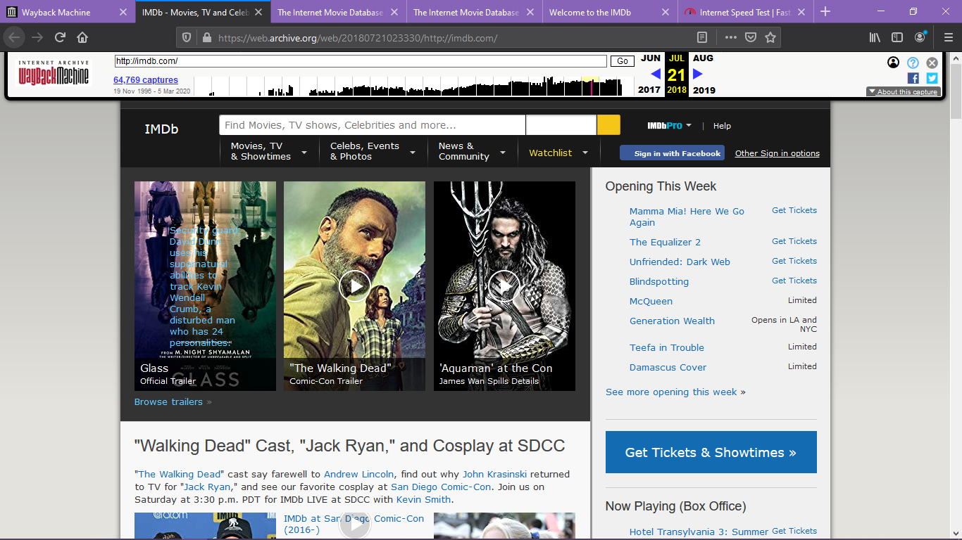

**Goodreads** is a social cataloging website that allows individuals to freely search its database of books, annotations, and reviews. Users can sign up and register books to generate library catalogs and reading lists. They can also create their own groups of book suggestions, surveys, polls, blogs, and discussions. The website's offices are located in San Francisco. The company is owned by the online retailer Amazon.

Goodreads was founded in December 2006 and launched in January 2007 by Otis Chandler and Elizabeth Khuri Chandler. In December 2007, the site had over 650,000 members and over 10,000,000 books had been added.

* The graphics changes through time
* In 2007 it does not have sign up form on the home page
* In 2019 it add love list on the home page

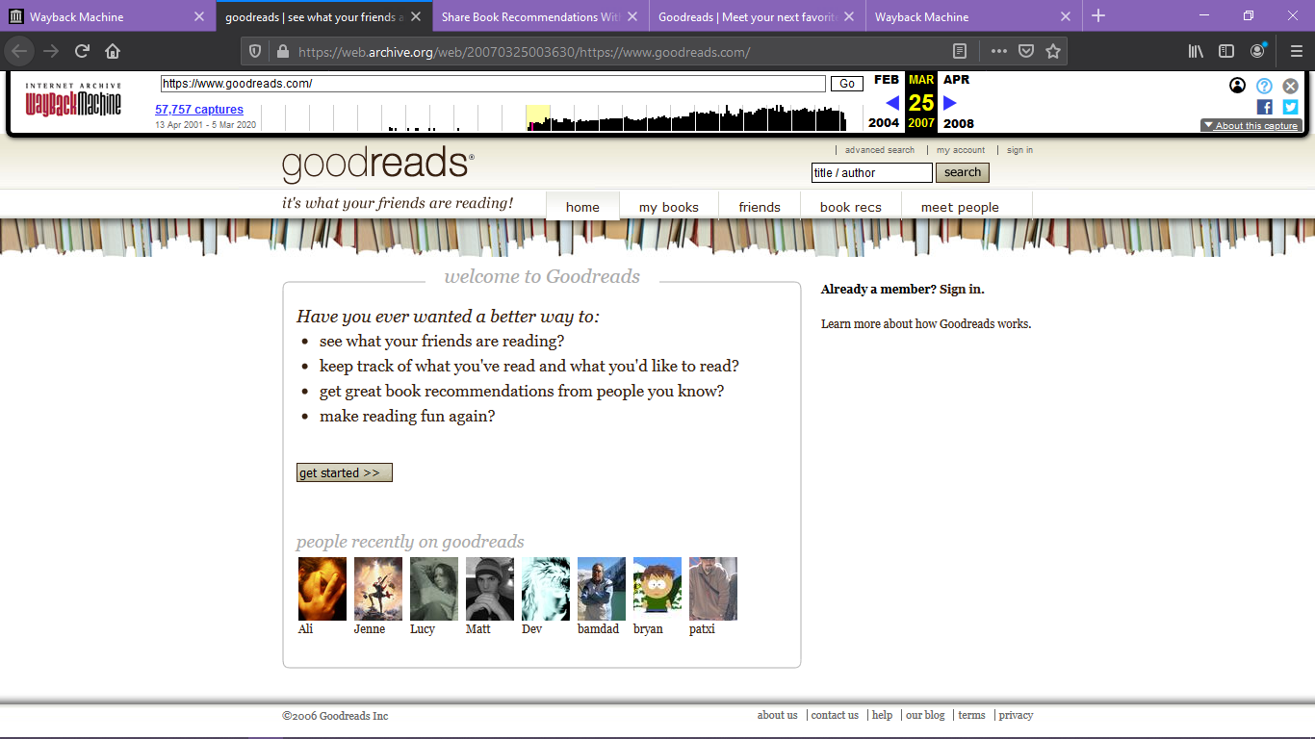

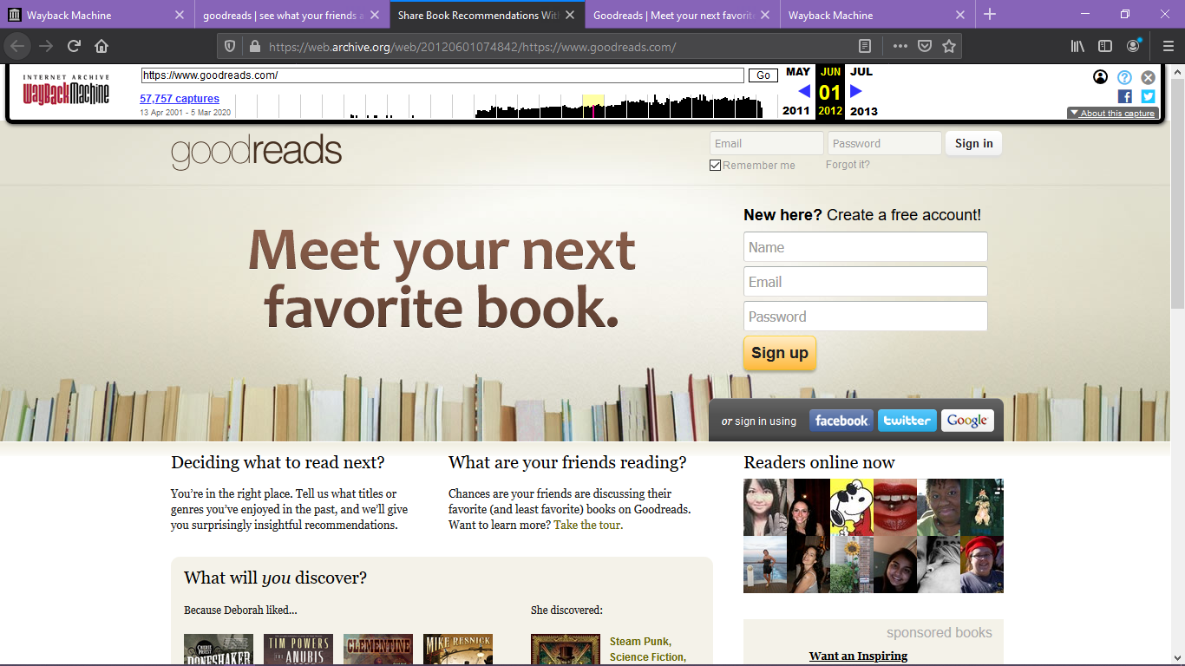

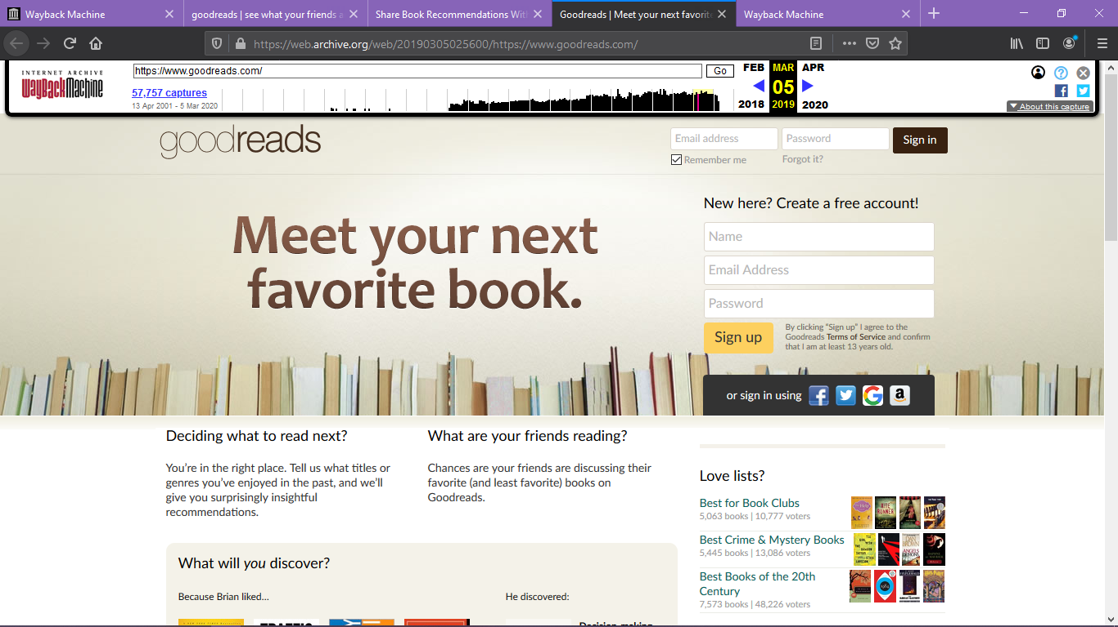

**Amazon** is an American multinational technology company based in Seattle that focuses on e-commerce, cloud computing, digital streaming, and artificial intelligence. Amazon.com was launched in July 1995. The logo was an abstract letter 'A' with a winding river flowing through it and the words Amazon.com, Earth’s biggest bookstore at the bottom.

Amazon is known for its disruption of well-established industries through technological innovation and mass scale. It is the world's largest online marketplace, AI assistant provider, and cloud computing platform as measured by revenue and market capitalization. Amazon was founded by Jeff Bezos in Bellevue, Washington, in July 1994. The company initially started as an online marketplace for books but later expanded to sell electronics, software, video games, apparel, furniture, food, toys, and jewelry.

Looking of amazon website in different years

Feb 29 2000

* The quality is poor
* Use of tabbed navigation
* zShops Was created

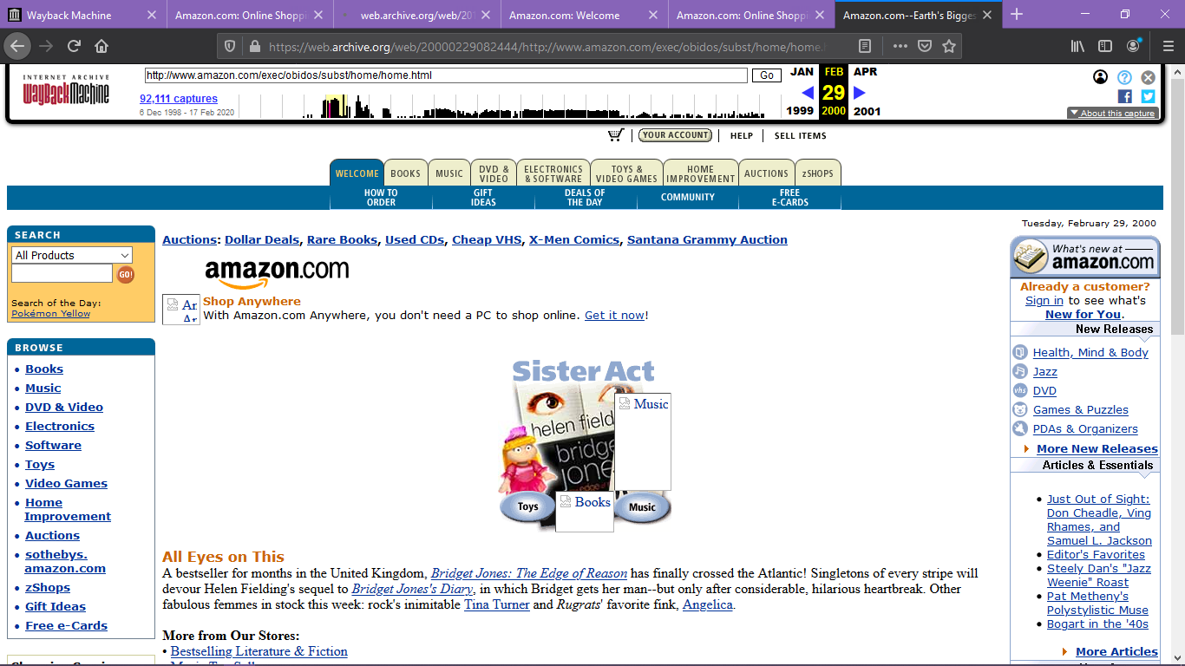

Jan 13 2004

* Amazon added additional categories such as eBooks, baby items, cell phones, and video games
* Some graphic flair added

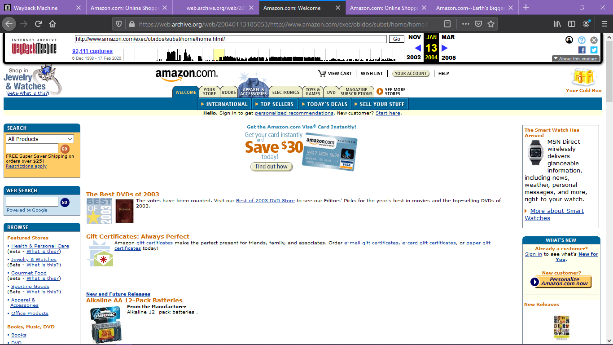

Mar 05 2015

* The homepage moved to a modular design
* Amazon dropped almost all traces of bold colors in the borders and background. Orange fonts were used prominently to show prices and bolded text

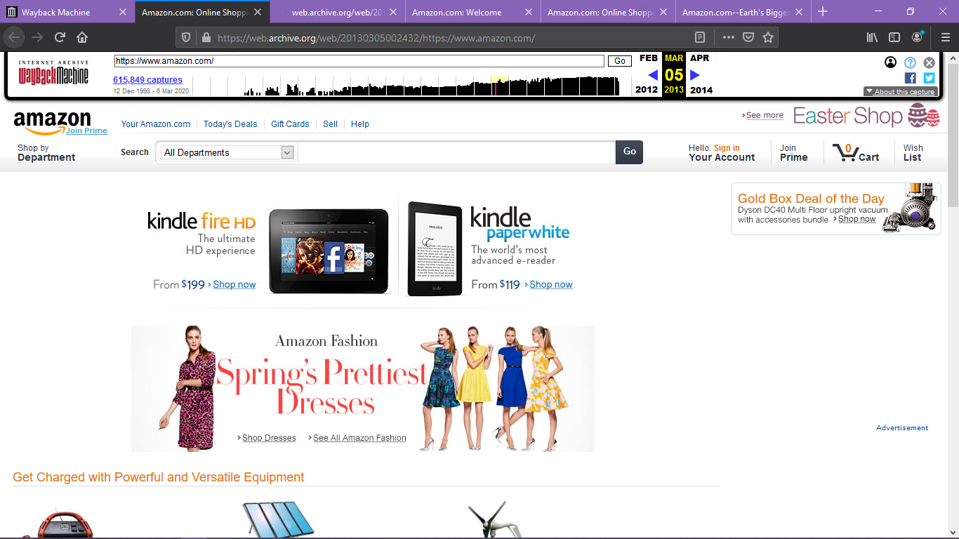

Apr 14 2019

* Transform into a more Spartan look with fewer items for sale on the homepage
* Promotional banner ad at the top of the homepage added

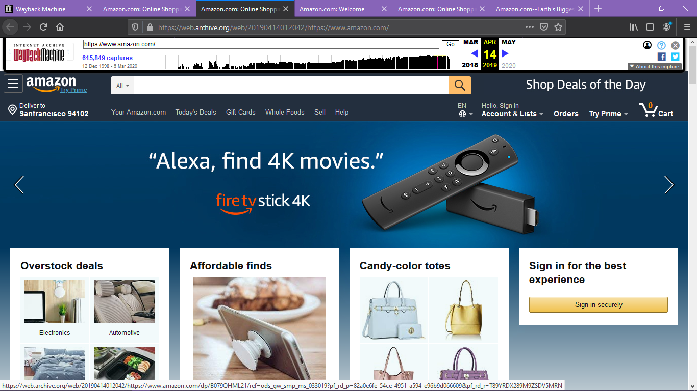

**YouTube** is an American video-sharing platform headquartered in San Bruno, California. Chad Hurley, Steve Chen, and Jawed Karim created the service in February 2005. Google bought the site in November 2006 for US$1.65 billion; YouTube now operates as one of Google's subsidiaries.

YouTube allows users to upload, view, rate, favorites, share, add to playlists, flag, report, comment on videos, and subscribe to other users.

There is tab, graphics, side bar difference between homepage

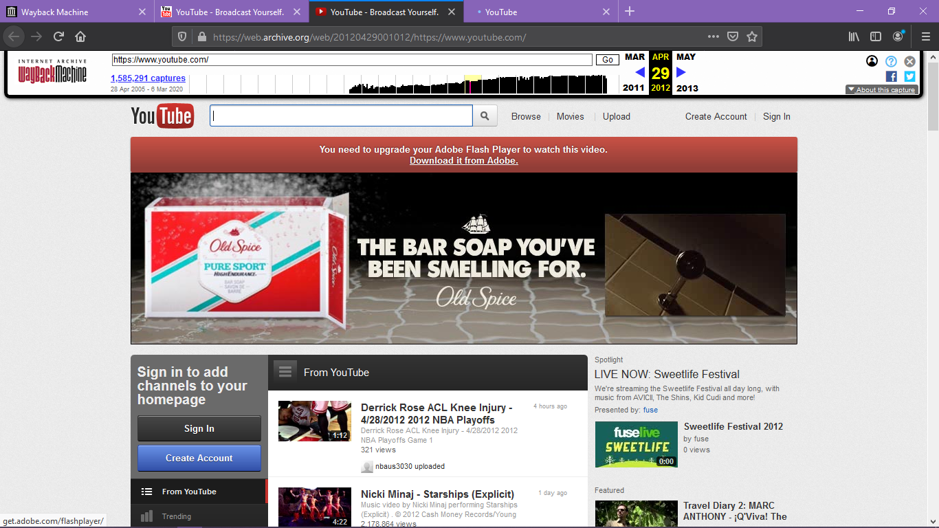

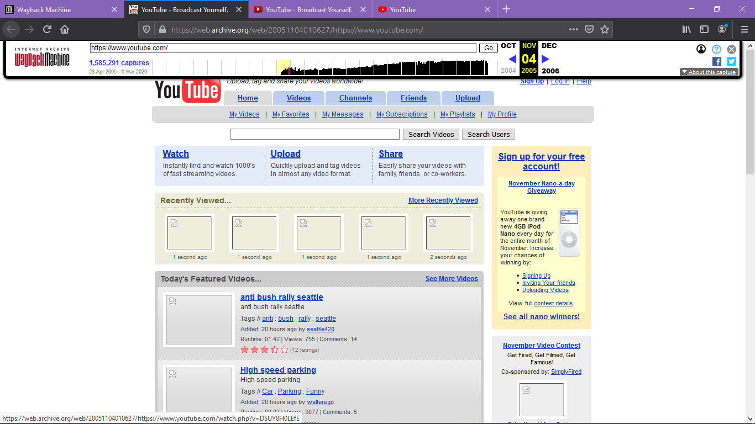

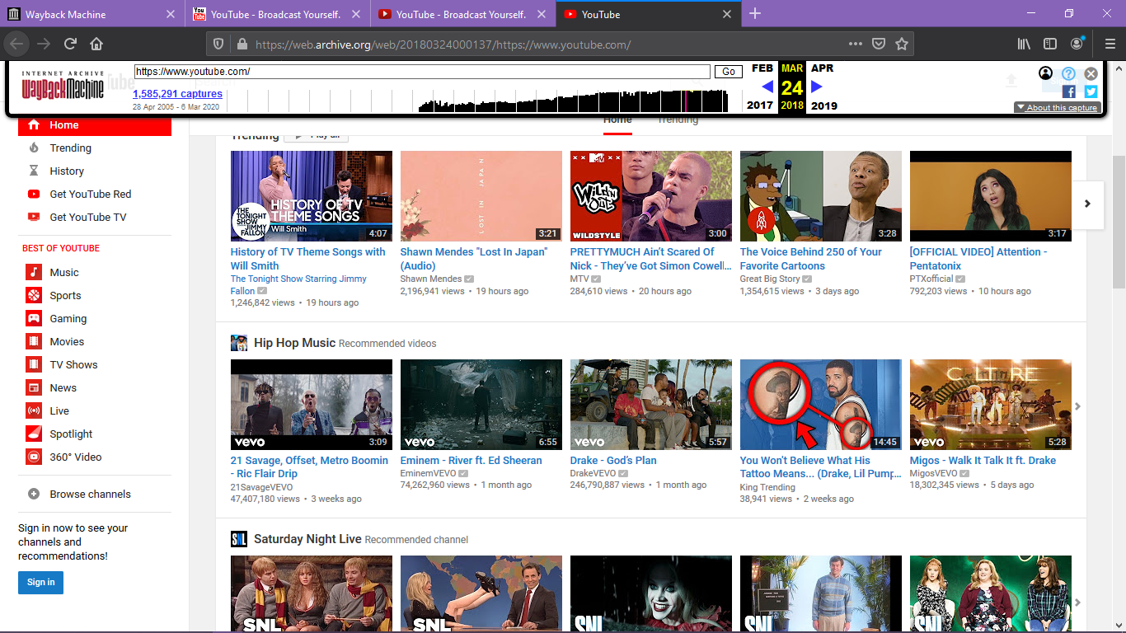

**Facebook** started as just a website for Harvard students by 2005 it was opening up to other schools the profile pages were plain there was also a notification on your profile that said 'this is you'. 2006 was when the mini-fee was born by 2007 anyone who is 13 or with an email could access Facebook. this was also the year that the new feed launched, which meant you could see that all your friends had been doing since the last time you logged in in 2009 Facebook goes mobile by 2010 the website had taken over the world, in 2011 Facebook launched a whole new design .you could add a cover photo since 2011 Facebooks login page and the site hasn't changed a lot

* There is a sign up form on homage except 2010
* Number of entity’s increased in 2015

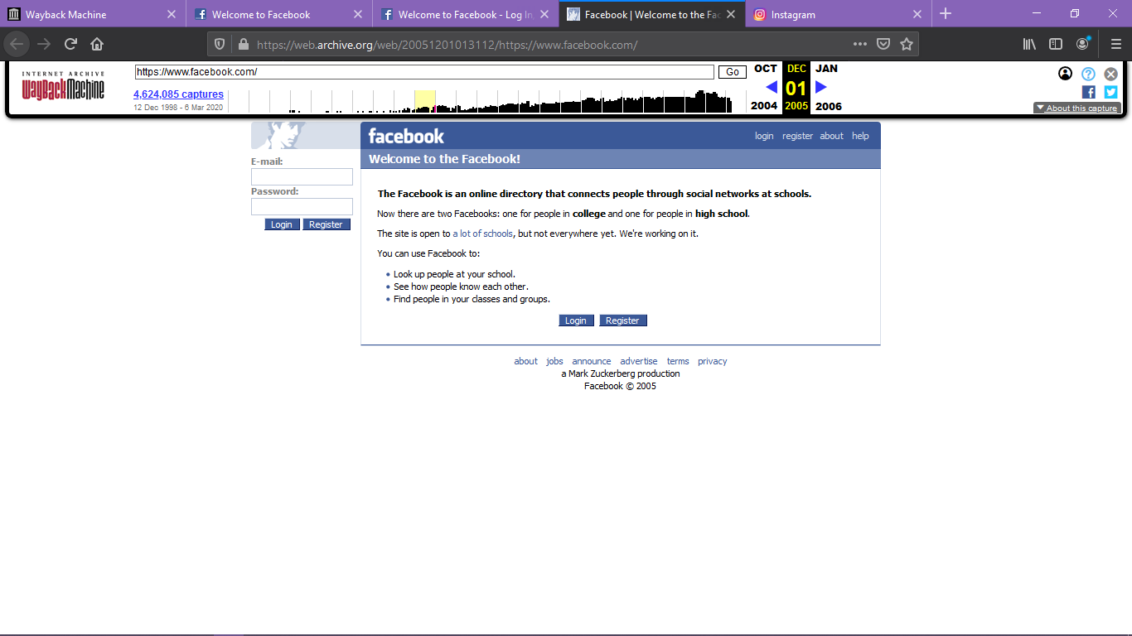

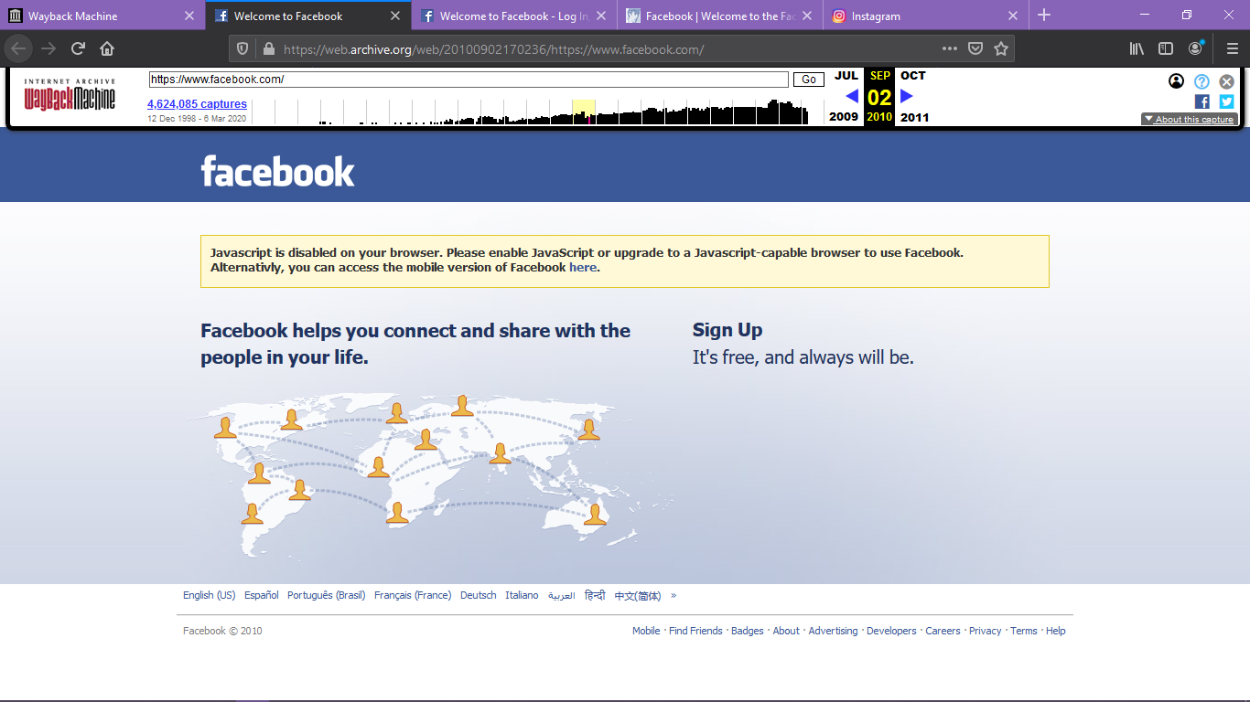

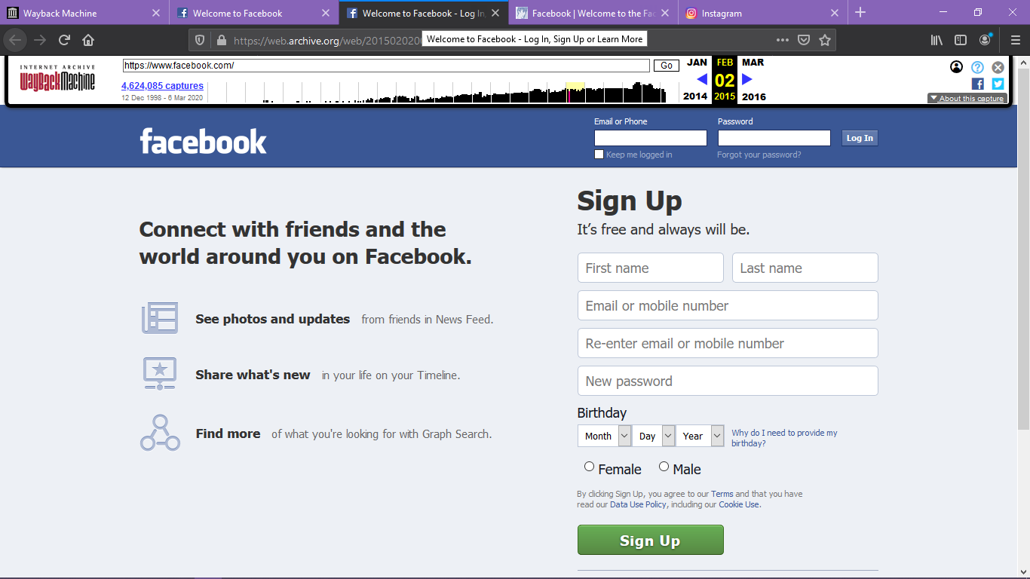

**Instagram** was officially launched in October 2010 and was available exclusively to iPhone users. The concept was simple: an app that lets you add filters to your photos and share them with your social circle.

For over five years, the way Instagram’s feed was filtered remained more or less unchanged. However, in March 2016, the Instagram feed got a total makeover. To reduce missed posts, Instagram officially switched from displaying content chronologically to using an algorithm to sort posts.

May 2016: Instagram unveils a new logo to mixed reactions

August 2016: Stories are added that allow users to share temporary videos and photos with their friends. These Stories are playable for up to 24 hours

* It added sign up form in hoe page

